TACD Tutorial 4

Ketaki Mahajan / B-1 16014022050

09/09/2024

1. Reduce the DFA and test the reduced DFA in JFLAP-----------------------------10M

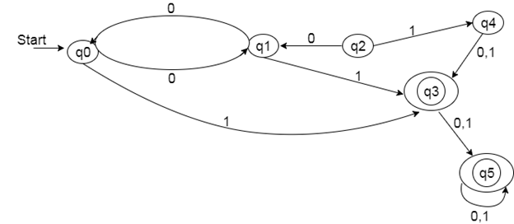

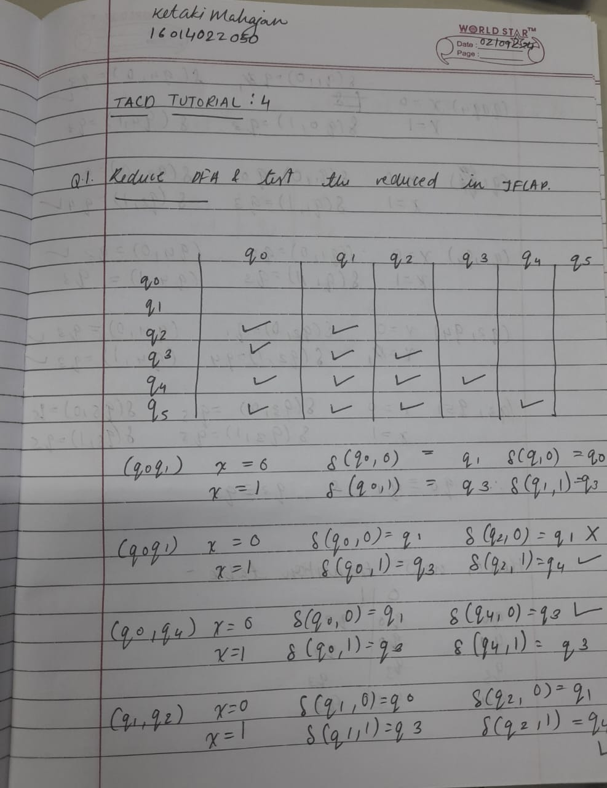

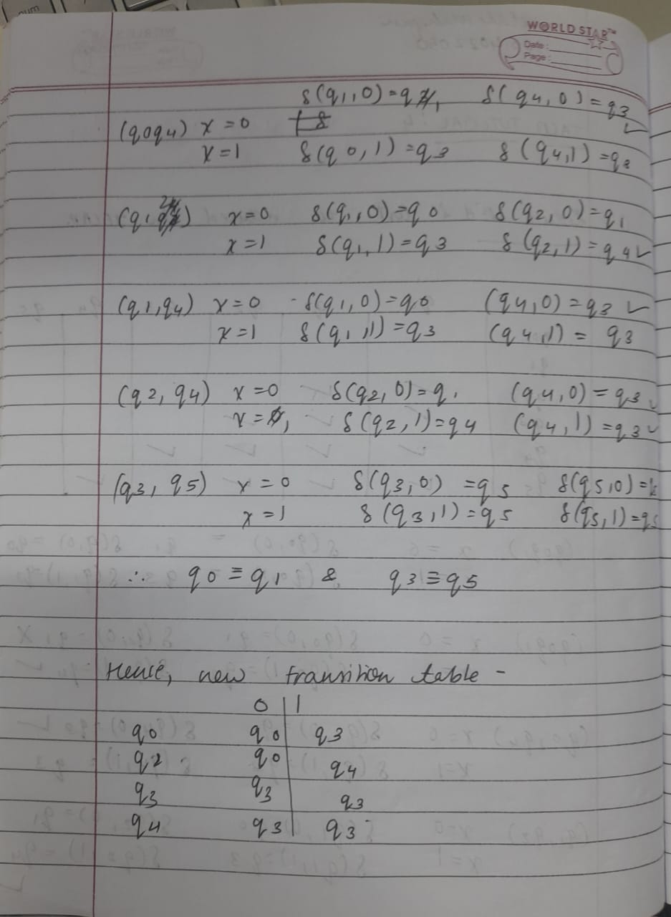

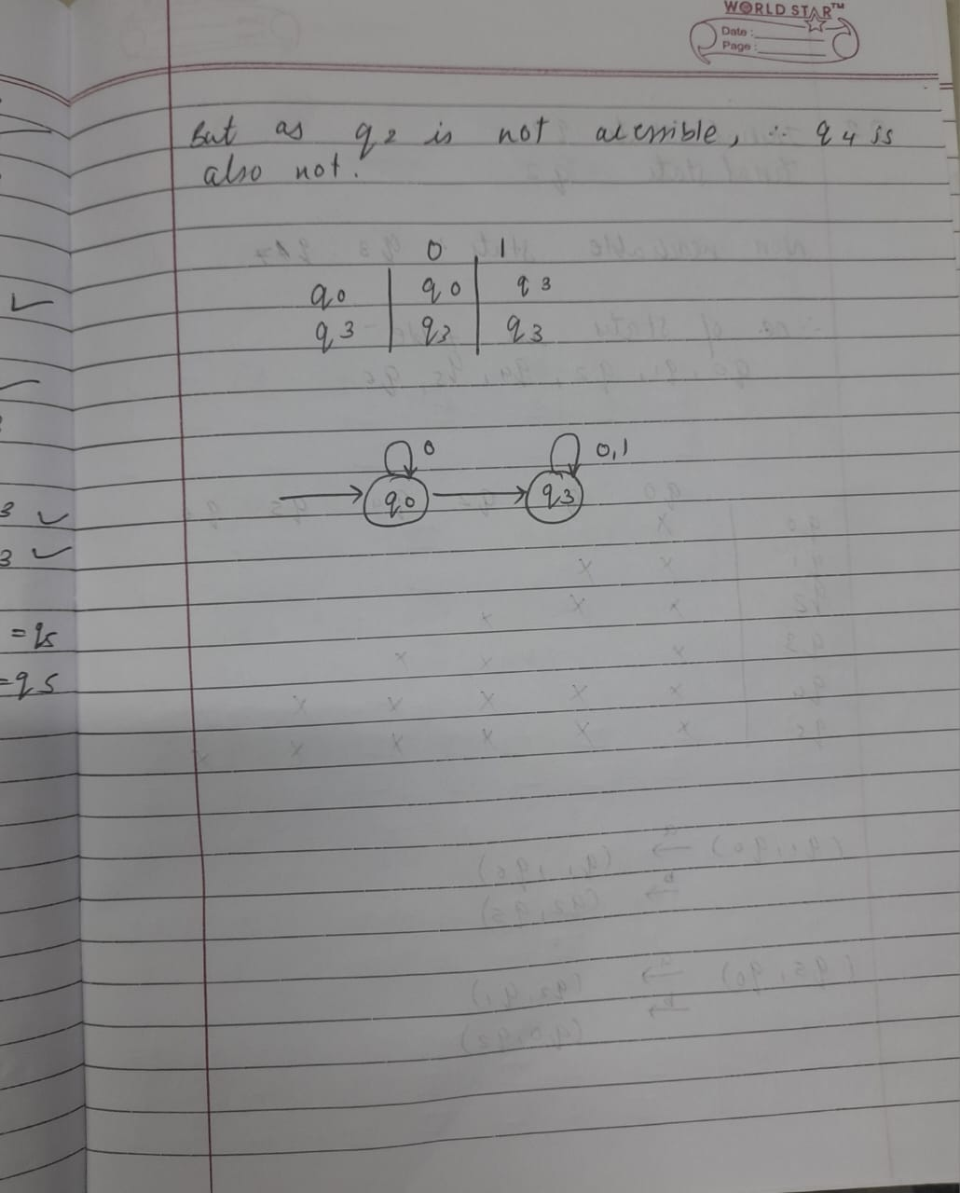

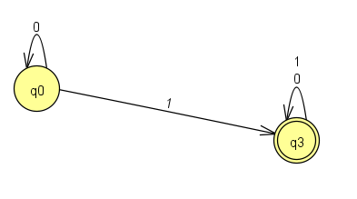

1. Reduce the given DFA using equivalence-----------------------------------7M

|  |  |  |
| --- | --- | --- |
|  | **0** | **1** |
| q0 | q1 | q5 |
| q1 | q6 | q2 |
| *q2 | q0 | q2 |
| q3 | q2 | q6 |
| q4 | q7 | q5 |
| q5 | q2 | q0 |
| q6 | q6 | q4 |
| q7 | q6 | q2 |

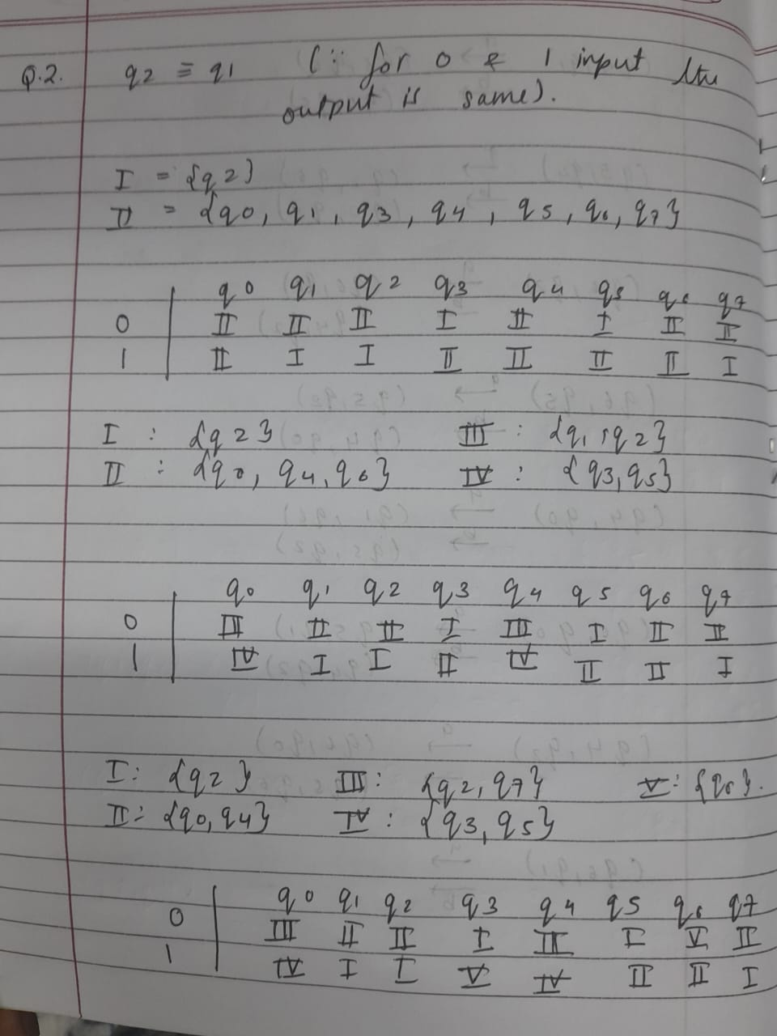

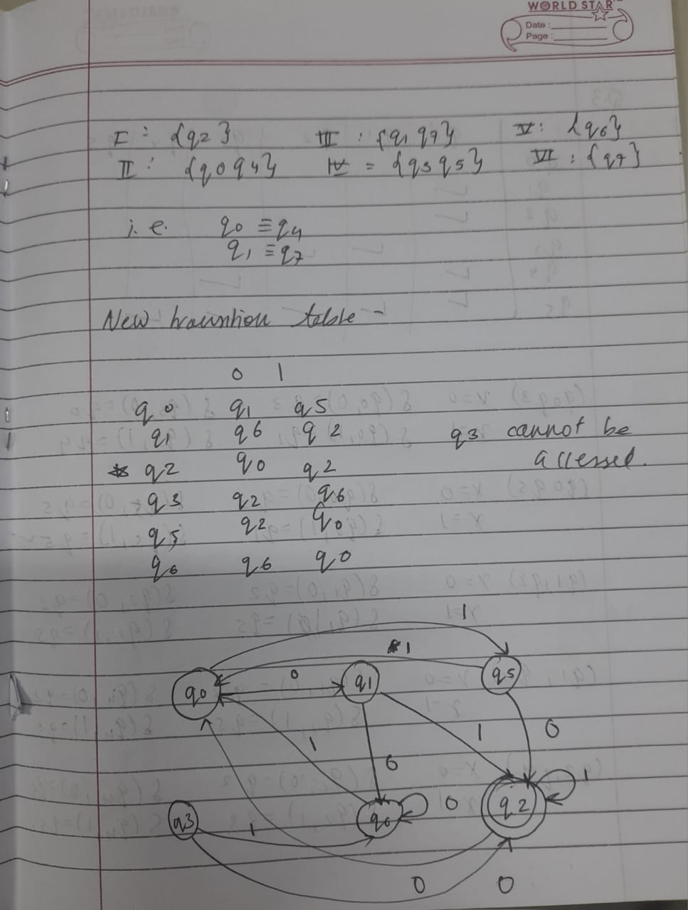

1. Reduce the given DFA using Myhill Nerode Theorem -------------------------8M

